Hardware Testing

# Overview:

An ESP32 microcontroller is being used to interact with the static and dynamic hardware implementations on the Pynq-Z2. Some of the pins of the ESP32 will be used for input/output interactions while some onboard pins/LEDs of the Pynq-Z2 will be used. Each implementation will be notated with a corresponding “Pin Layout diagram.”

# Hardware Documents:

## Official documentation for Signal → PL Pin for Pynq Z2

<https://d2m32eurp10079.cloudfront.net/Download/pynqz2_user_manual_v1_0.pdf>

## HiLetgo NodeMCU-32S Pinout

## Picture of testing setup

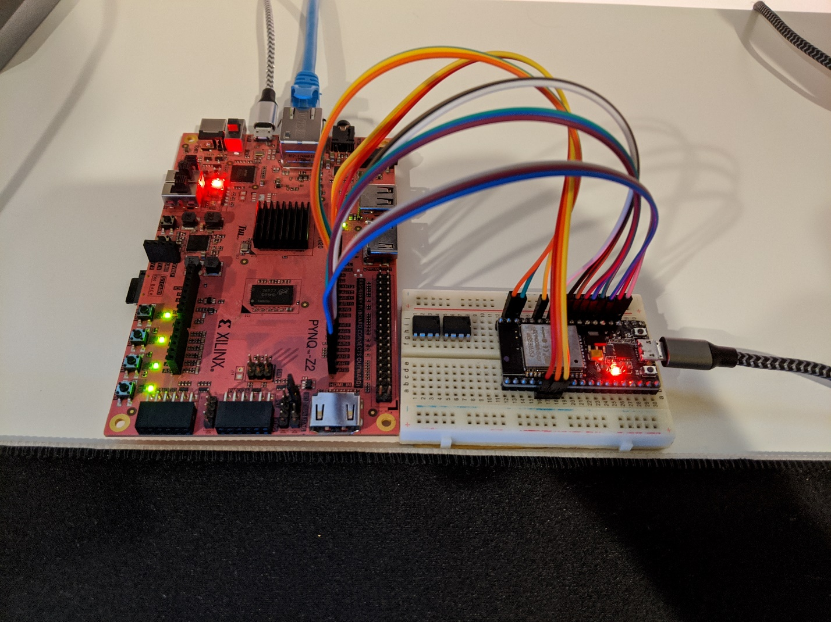

|  |  |
| --- | --- |
| Wiring Table | |
| ESP32 GPIO Pin Name | **Pynq Z2 Pin Name/Package Pin** |
| GPIO25 | AR0/T14 |
| GPIO2 | AR1/U12 |
| GPIO15 | AR2/U13 |
| GPIO17 | AR3/V13 |
| GPIO16 | AR4/V15 |
| GPIO4 | AR5/T15 |
| GPIO19 | AR6/R16 |
| GPIO18 | AR7/U17 |
| GPIO5 | AR8/V17 |
| GPIO23 | AR9/V18 |
| GPIO22 | AR10/T16 |
| GPIO21 | AR11/R17 |
| GPIO32 | AR12/P18 |
| GPIO35 | AR13/N17 |

# Static Hardware Implementation: PASS *XBar.v*

|  |  |  |  |  |  |
| --- | --- | --- | --- | --- | --- |
|  | Pin Layout | | | | |
| Signal Count | Data Signal Name /  (Sub signal count) | | ESP32 Pin Name  (if connected) | Pynq Z2 Pin Name | Package Pin | |
| 1 | Clk | | GPIO2 | AR1 | U12 | |
| 2 | Rst | | GPIO25 | AR0 | T14 | |
| 6 | flatInputPort | (3) | GPIO15 | AR2 | U13 | |
| 7 | flatInputPort | (2) | GPIO17 | AR3 | V13 | |
| 8 | flatInputPort | (1) | GPIO16 | AR4 | V15 | |
| 9 | flatInputPort | (0) | GPIO4 | AR5 | T15 | |
| 6 | flatOutputPort | (3) | N/A | LD3 | M14 | |
| 7 | flatOutputPort | (2) | N/A | LD2 | N16 | |
| 8 | flatOutputPort | (1) | N/A | LD1 | P14 | |
| 9 | flatOutputPort | (0) | N/A | LD0 | R14 | |
| 10 | AddressSelect | (4) | GPIO19 | AR6 | R16 | |
| 11 | AddressSelect | (3) | GPIO18 | AR7 | U17 | |
| 12 | AddressSelect | (2) | GPIO5 | AR8 | V17 | |
| 13 | AddressSelect | (1) | GPIO23 | AR9 | V18 | |
| 14 | AddressSelect | (0) | GPIO22 | AR010 | T16 | |

# Dynamic Hardware Implementation: PASS *dynamicMulti.v*

|  |  |  |  |  |  |
| --- | --- | --- | --- | --- | --- |
|  | Pin Layout | | | | |
| Signal Count | Data Signal Name /  (Sub signal count) | | ESP32 Pin Name  (if connected) | Pynq Z2 Pin Name | Package Pin | |
| 1 | Clk | | GPIO2 | AR1 | U12 | |
| 2 | Rst | | GPIO25 | AR0 | T14 | |
| 3 | bufferEN | | GPIO15 | AR2 | U13 | |
| 4 | bufferSelect | | GPIO17 | AR3 | V13 | |
| 5 | chunkCount | | N/A | SW0 | M20 | |
| 6 | bufferRD | | GPIO16 | AR4 | V15 | |
| 7 | mReady | | N/A | LD4 Green | G17 | |
| 8 | mStart | | GPIO4 | AR5 | T15 | |
|  | chunkCount | | N/A | SW0 | M20 | |
| 9 | FULL | (1) | N/A | LD5 Blue | G14 | |
| 10 | FULL | (0) | N/A | LD4 Blue | L15 | |
| 11 | dataIn | (3) | GPIO19 | AR6 | R16 | |
| 12 | dataIn | (2) | GPIO18 | AR7 | U17 | |
| 13 | dataIn | (1) | GPIO5 | AR8 | V17 | |
| 14 | dataIn | (0) | GPIO23 | AR9 | V18 | |
| 15 | dataOut | (3) | N/A | LD3 | M14 | |
| 16 | dataOut | (2) | N/A | LD2 | N16 | |
| 17 | dataOut | (1) | N/A | LD1 | P14 | |
| 18 | dataOut | (0) | N/A | LD0 | R14 | |

# Static Hardware Implementation: NOTEST *staticXBarMulti.v*

|  |  |  |  |  |  |
| --- | --- | --- | --- | --- | --- |
|  | Pin Layout | | | | |
| Signal Count | Data Signal Name /  (Sub signal count) | | ESP32 Pin Name  (if connected) | Pynq Z2 Pin Name | Package Pin | |
| 1 | Clk | | GPIO2 | AR1 | U12 | |
| 2 | Rst | | GPIO25 | AR0 | T14 | |
| 3 | bufferSelect | | GPIO15 | AR2 | U13 | |
| 4 | chunkCount | | N/A | SW0 | M20 | |
| 5 | mStart_in | | GPIO17 | AR3 | V13 | |
| 6 | mStart_out | | GPIO16 | AR4 | V15 | |
| 7 | outputSelect | (1) | N/A | SW1 | M19 | |
| 8 | outputSelect | (0) | N/A | SW0 | M20 | |
| 9 | mReady_in | (3) | NC | NC | A20 | |
| 10 | mReady_in | (2) | NC | NC | B19 | |
| 11 | mReady_in | (1) | NC | NC | B20 | |
| 12 | mReady_in | (0) | N/A | LD5 Red | G14 | |
| 13 | mReady_out | (3) | NC | NC | F19 | |
| 14 | mReady_out | (2) | NC | NC | F20 | |
| 15 | mReady_out | (1) | NC | NC | G15 | |
| 16 | mReady_out | (0) | N/A | LD4 Red | L15 | |
| 17 | bufferRD_in | (3) | NC | NC | D20 | |
| 18 | bufferRD_in | (2) | NC | NC | E17 | |
| 19 | bufferRD_in | (1) | NC | NC | E18 | |
| 20 | bufferRD_in | (0) | GPIO4 | AR5 | T15 | |
| 21 | bufferRD_out | (3) | NC | NC | E19 | |
| 22 | bufferRD_out | (2) | NC | NC | F16 | |
| 23 | bufferRD_out | (1) | NC | NC | F17 | |
| 24 | bufferRD_out | (0) | GPIO19 | AR6 | R16 | |
| 25 | AddressSelect | (4) | GPIO18 | AR7 | U17 | |
| 26 | AddressSelect | (3) | NC | NC | C20 | |
| 27 | AddressSelect | (2) | NC | NC | D18 | |
| 28 | AddressSelect | (1) | NC | NC | D19 | |
| 29 | AddressSelect | (0) | GPIO5 | AR8 | V17 | |
| 30 | dataIn | (3) | GPIO23 | AR9 | V18 | |
| 31 | dataIn | (2) | GPIO22 | AR10 | T16 | |
| 32 | dataIn | (1) | GPIO21 | AR11 | R17 | |
| 33 | dataIn | (0) | GPIO32 | AR12 | P18 | |
| 34 | dataOut | (3) | N/A | LD3 | M14 | |
| 35 | dataOut | (2) | N/A | LD2 | N16 | |
| 36 | dataOut | (1) | N/A | LD1 | P14 | |
| 37 | dataOut | (0) | N/A | LD0 | R14 | |

# Dynamic Hardware Implementation: *dynamicXBarMulti.v*

|  |  |  |  |  |  |
| --- | --- | --- | --- | --- | --- |
|  | Pin Layout | | | | |
| Signal Count | Data Signal Name /  (Sub signal count) | | ESP32 Pin Name  (if connected) | Pynq Z2 Pin Name | Package Pin | |
| 1 | Clk | | GPIO18 | AR7 | U17 | |
| 2 | Rst | | GPIO32 | AR12 | P18 | |
| 3 | bufferSelect | | GPIO19 | AR6 | R16 | |
| 4 | chunkCount | | N/A | SW0 | M20 | |
| 5 | mStart_in | | GPIO22 | AR10 | T16 | |
| 6 | mStart_out | | GPIO21 | AR11 | R17 | |
| 7 | outputSelect | (1) | N/A | SW1 | M19 | |
| 8 | outputSelect | (0) | N/A | SW0 | M20 | |
| 9 | mReady_in | (3) | NC | NC | A20 | |
| 10 | mReady_in | (2) | NC | NC | B19 | |
| 11 | mReady_in | (1) | NC | NC | G14 | |
| 12 | mReady_in | (0) | N/A | LD5 Blue | G14 | |
| 13 | mReady_out | (3) | NC | NC | F19 | |
| 14 | mReady_out | (2) | NC | NC | F20 | |
| 15 | mReady_out | (1) | NC | NC | G15 | |
| 16 | mReady_out | (0) | N/A | LD4 Blue | L15 | |
| 17 | bufferRD_in | (3) | NC | NC | D20 | |
| 18 | bufferRD_in | (2) | NC | NC | E17 | |
| 19 | bufferRD_in | (1) | NC | NC | E18 | |
| 20 | bufferRD_in | (0) | GPIO4 | AR5 | T15 | |
| 21 | bufferRD_out | (3) | NC | NC | E19 | |
| 22 | bufferRD_out | (2) | NC | NC | F16 | |
| 23 | bufferRD_out | (1) | NC | NC | F17 | |
| 24 | bufferRD_out | (0) | GPIO35 | AR13 | N17 | |
| 25 | AddressSelect | (4) | GPIO23 | AR9 | V18 | |
| 26 | AddressSelect | (3) | NC | NC | C20 | |
| 27 | AddressSelect | (2) | NC | NC | D18 | |
| 28 | AddressSelect | (1) | NC | NC | D19 | |
| 29 | AddressSelect | (0) | GPIO16 | AR4 | V15 | |
| 30 | dataIn | (3) | GPIO0 | AR0 | T14 | |
| 31 | dataIn | (2) | GPIO2 | AR1 | U12 | |
| 32 | dataIn | (1) | GPIO15 | AR2 | U13 | |
| 33 | dataIn | (0) | GPIO17 | AR3 | V13 | |
| 34 | dataOut | (3) | N/A | LD3 | M14 | |
| 35 | dataOut | (2) | N/A | LD2 | N16 | |
| 36 | dataOut | (1) | N/A | LD1 | P14 | |
| 37 | dataOut | (0) | N/A | LD0 | R14 | |